LAB 11: APPLET IN JAVA

Name: Shreyas Sawant Div: D7A Roll No.: 55

Write a program to display (any two) a) house b) traffic Signal c) Joker Face in Applets.

a)House

CODE:

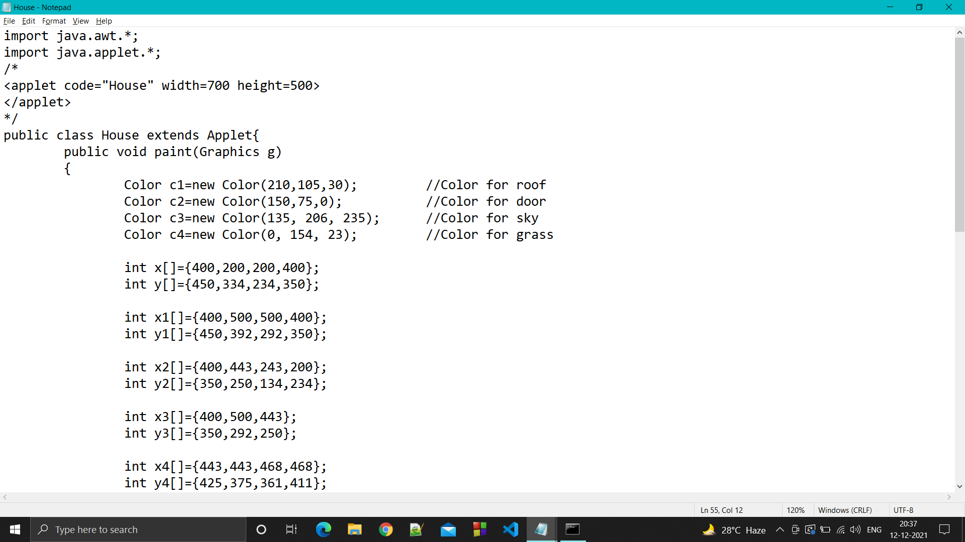

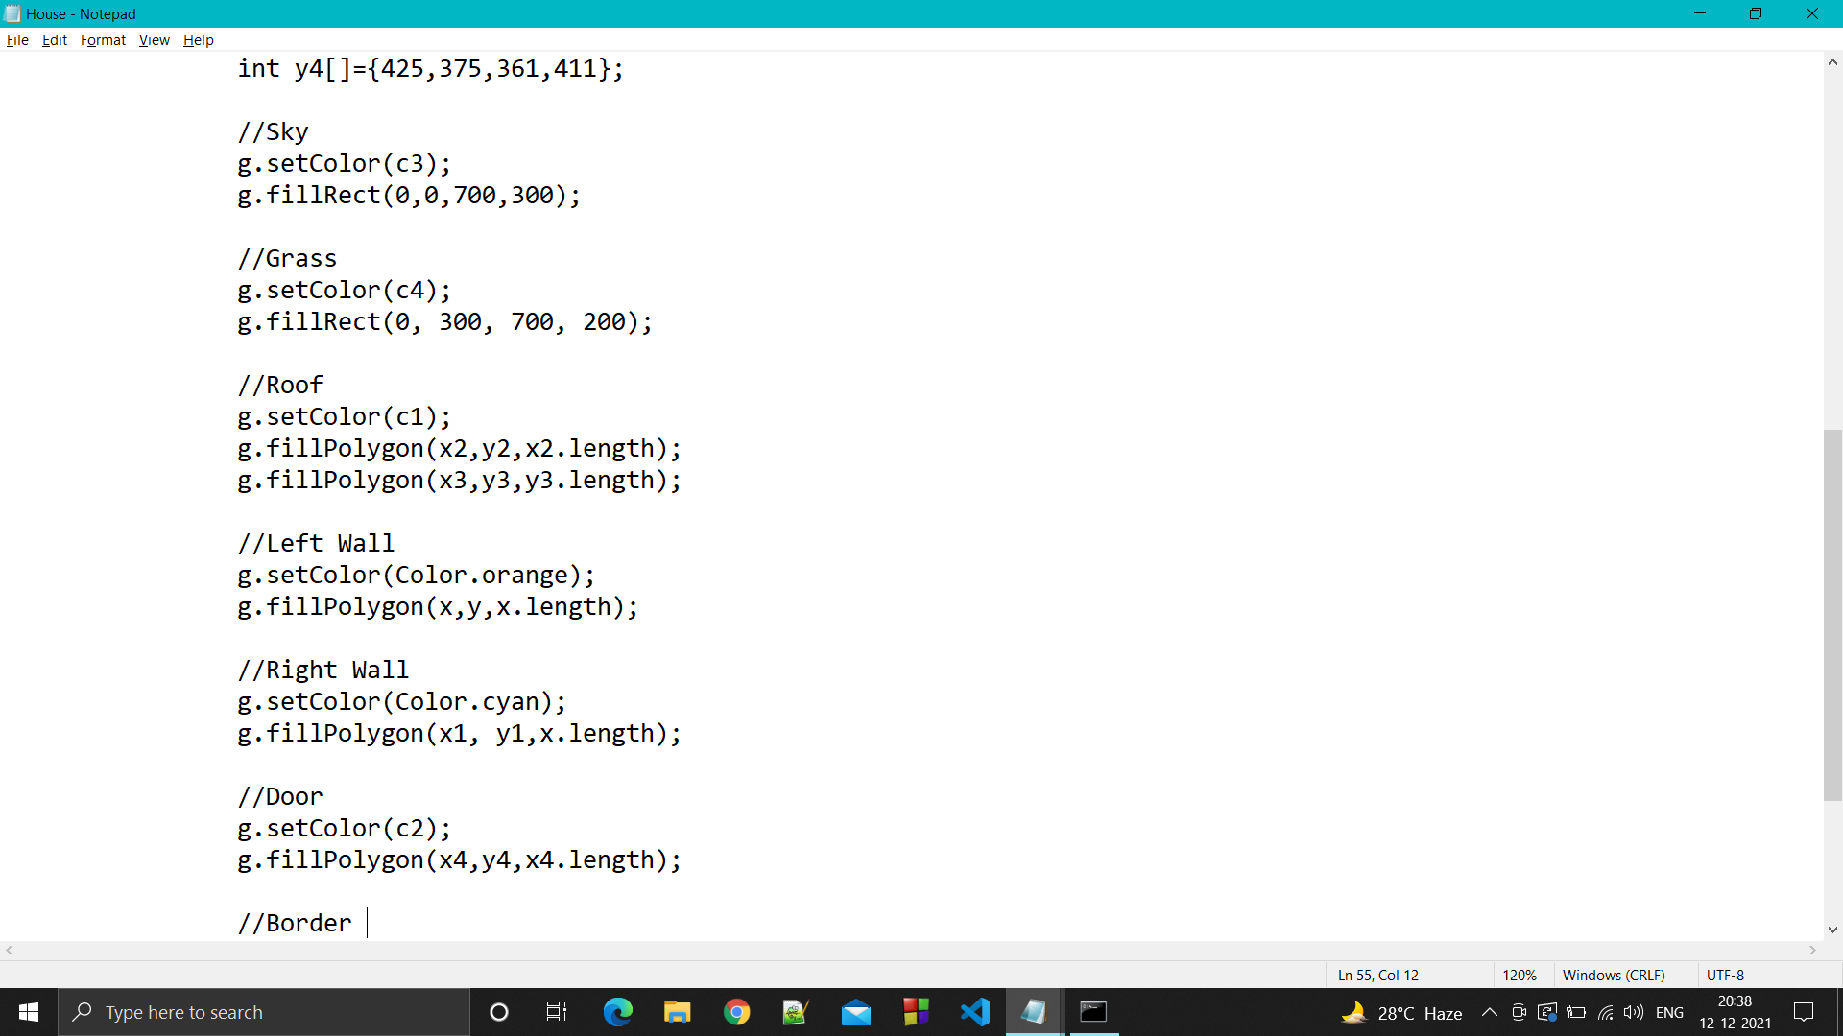

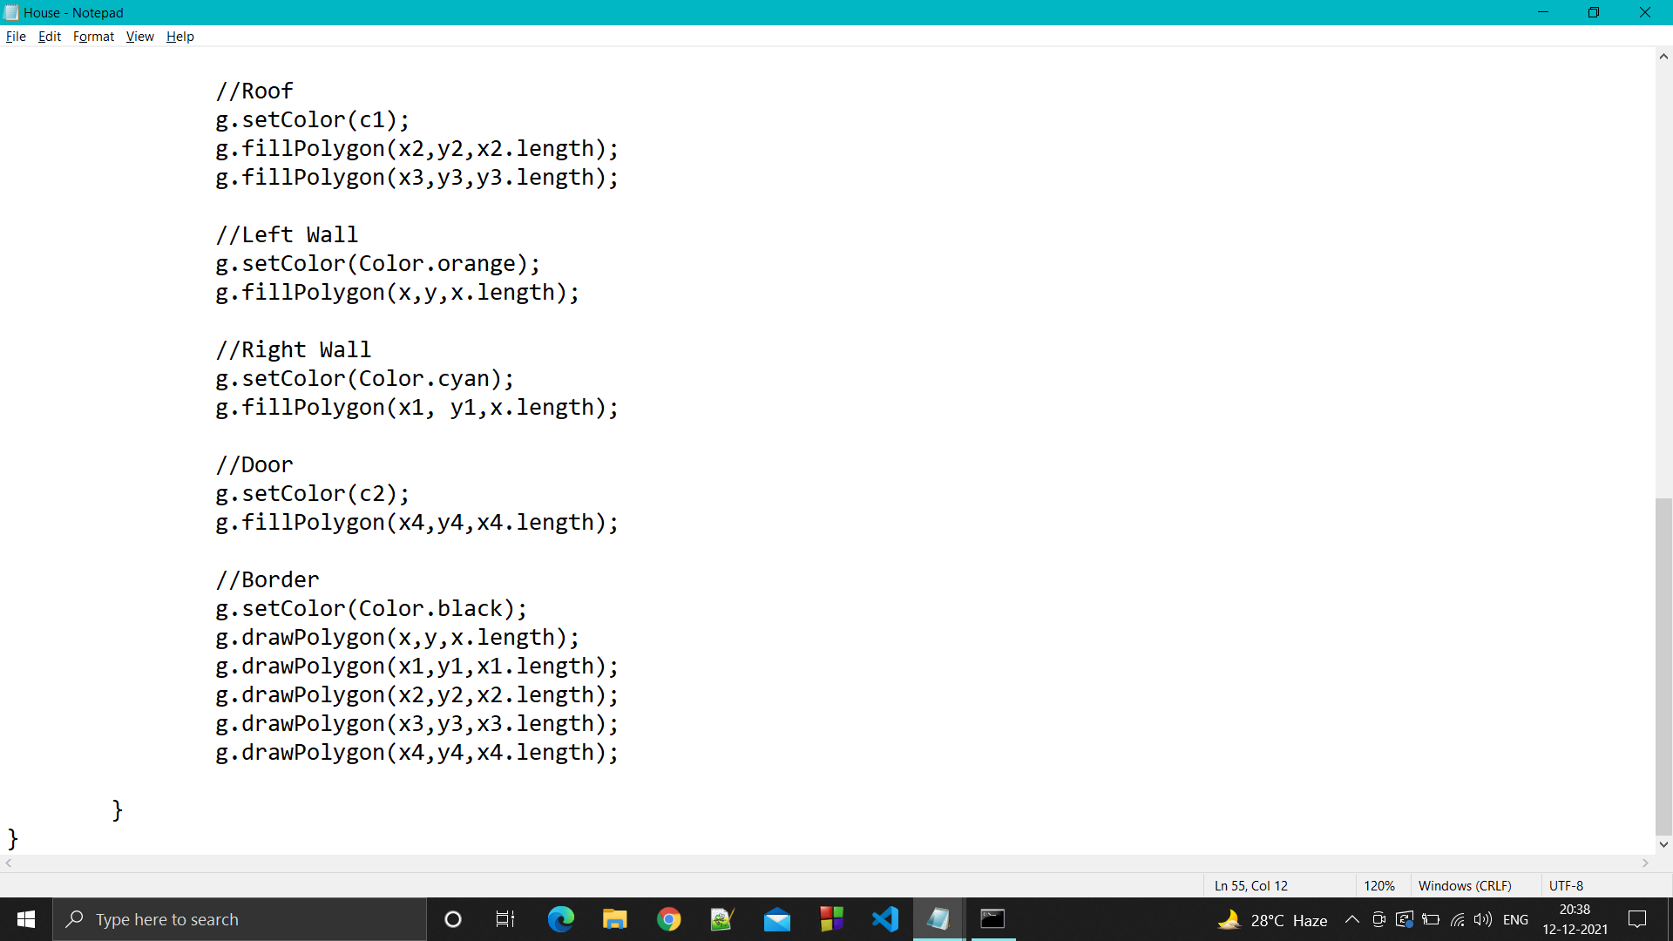

OUTPUT:

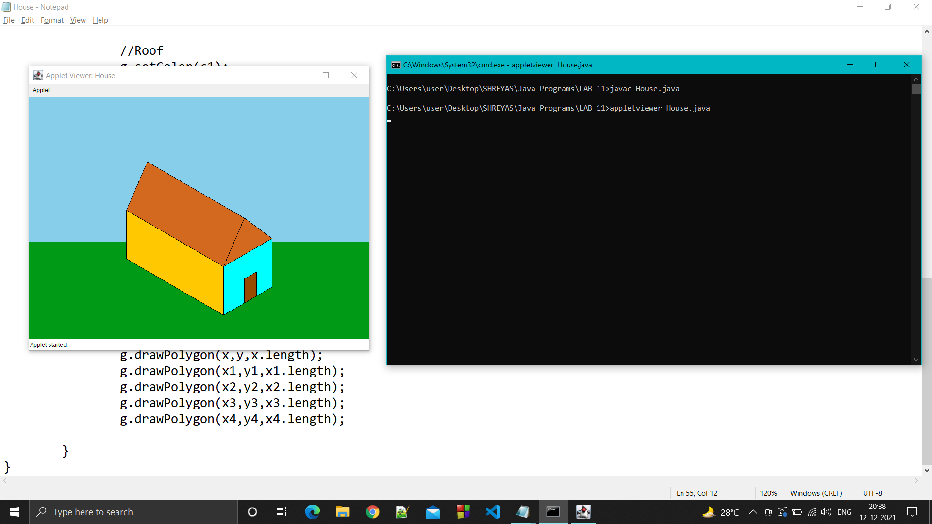

b) Traffic Signal

CODE:

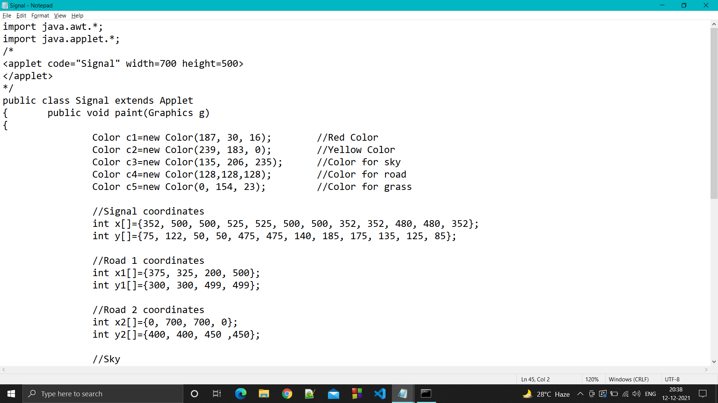

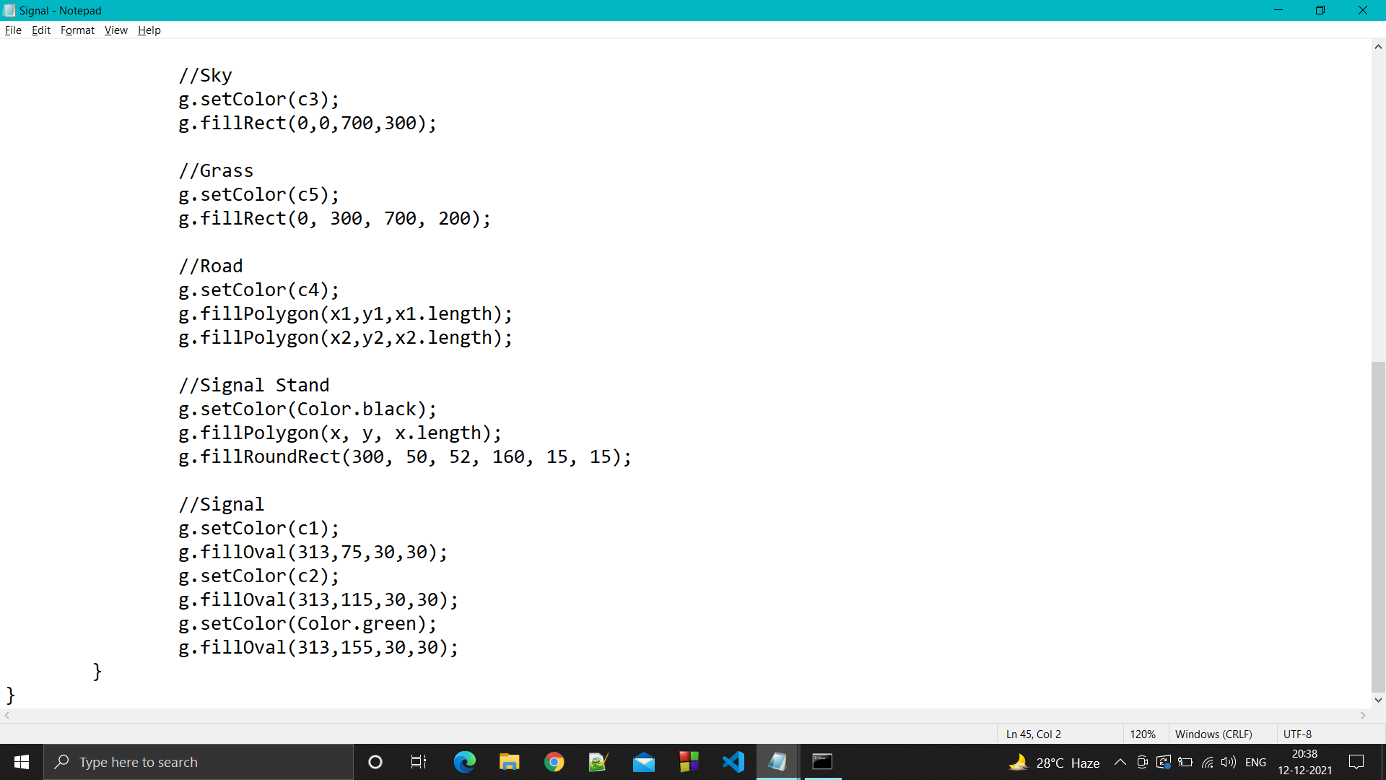

OUTPUT

